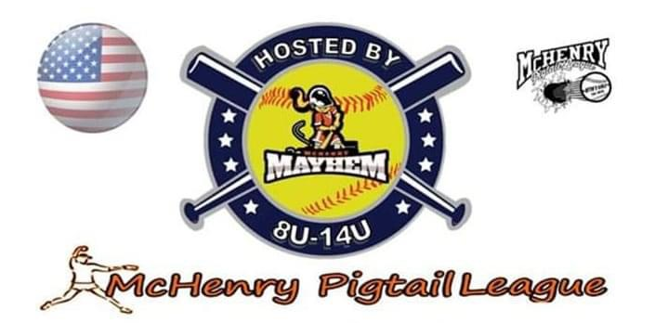
Frenzy Round Robin
Saturday July 25, 2026
Open to Tournament/All-Star Teams (8u,10u,12u,14u)
(4 Teams Per Division) Single Day Event
1st Place Medals
Cost: $300 per team
Location: Petersen Park 4300 Petersen Park Rd. McHenry, IL 60050
Team Name:_________________________ Age:_________
Manager:_____________________ Email:__________________________ Cell:_____________
Team Name:_________________________ Age:_________
Manager:_____________________ Email:__________________________ Cell:_____________
Team Name:_________________________ Age:_________
Manager:_____________________ Email:__________________________ Cell:_____________
Team Name:_________________________ Age:_________
Manager:_____________________ Email:__________________________ Cell:_____________
Please Email Completed Registration form to mpltournamentcoordinator@gmail.com
Once you receive confirmation of your Registration Please Send payment
Mail to: McHenry Pigtail League 518 S. Route #31 #132 McHenry, IL 60050
Make Checks Payable to McHenry Pigtail League

